Scottish Bread Championship 2026
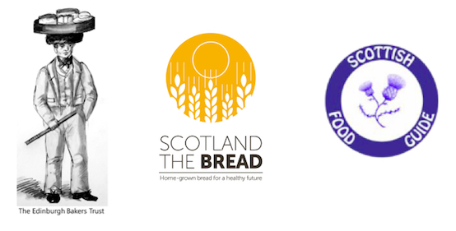
ENTRY FORM – BAKER’S DETAILS

Entrants are solely responsible for the accuracy, eligibility and legibility of their entries.

Please complete & return by email to wendy@wendybarrie.co.uk

NAME
BUSINESS NAME
(where applicable)
ADDRESS

TELEPHONE NUMBER
EMAIL
WEBSITE
(optional)
TWITTER /X/INSTAGRAM
(optional)
OFFICE USE:
Entry code

Scottish Bread Championship 2026
ENTRY FORM – ITEM DETAILS – please duplicate & complete this form for each & every loaf/pastry. The entry fee is £5.00 per entry. Please pay online here: https://scotlandthebread.org/product/scottish-bread-championship-2026-entry-fee/
& email your completed entry forms & photo to wendy@wendybarrie.co.uk
Entries close Friday 20th February 2026
CLASS Number(s) | SHORT DESCRIPTOR/PRODUCT NAME FOR JUDGING DISPLAY LABEL
NAME OF BAKER / BAKERY: (for organiser identification - not visible on the day)
FULL DESCRIPTION OF ENTRY
(N.B. It is not in the spirit of the competition to reveal your identity so please make every effort not to use obvious logos/designs on your loaves). MAXIMUM WORD COUNT IN TOTAL: 350 WORDS
Ingredient list
Grain/flour type and source
Nutritional information (as relevant for class entered)
Provenance of ingredients (as relevant for class entered)
Heritage of recipe (as relevant for class entered)
The story – idea/purpose behind the loaf
If this box is  unchecked no  products will  be judged |  | I hereby confirm that all products entered in this competition conform to the basic standard of the Real Bread Campaign, i.e. they contain no additives or processing aids.
The judges will base their scores on appearance, crust/bake, texture/crumb, flavour & integrity (assessing how well you have realised your intention and ambition)

